

PRACTICAL-01

AIM: To implementation and time analysis of sorting algorithms.Bubble sort,Selection Sort,Insertion sort,Merge sorta and Quick sort.

BUBBLE SORT

ALGORITHM:

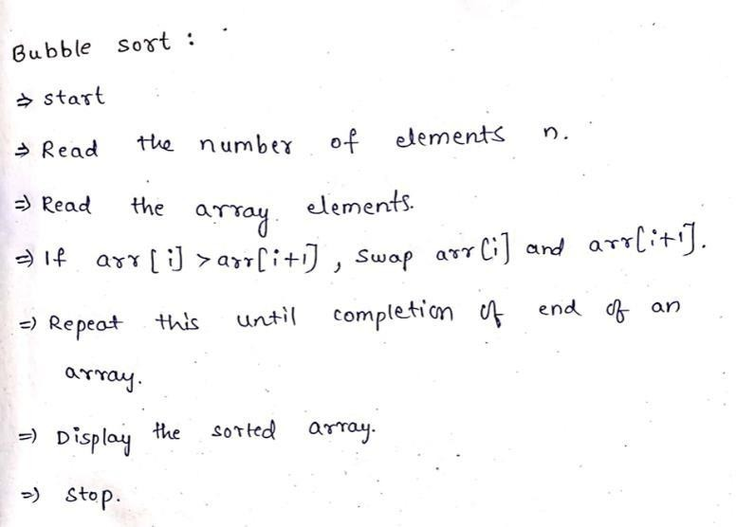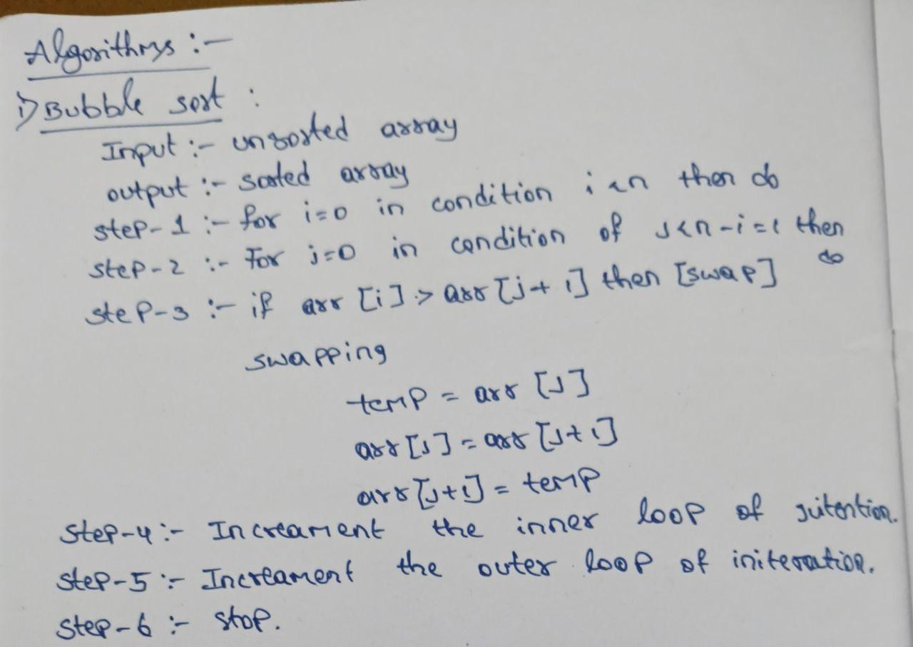

PROGRAM:
#include <iostream> using namespace std;
void bubbleSort(int arr[], int n) { for (int i = 0; i < n - 1; i++) {
for (int j = 0; j < n - i - 1; j++) { if (arr[j] > arr[j + 1]) {
int temp = arr[j]; arr[j] = arr[j + 1]; arr[j + 1] = temp;
}
}
}


}

int main() { int n;
cout << "Enter number of elements: "; cin >> n;
int arr[n];
cout << "Enter array elements: "; for (int i = 0; i < n; i++) {
cin >> arr[i];
}

bubbleSort(arr, n);

cout << "Sorted elements: "; for (int i = 0; i < n; i++) {
cout << arr[i] << " ";
}
cout << endl;

return 0;
}

OUTPUT:
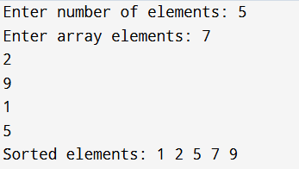



TIME COMPLEXITY:
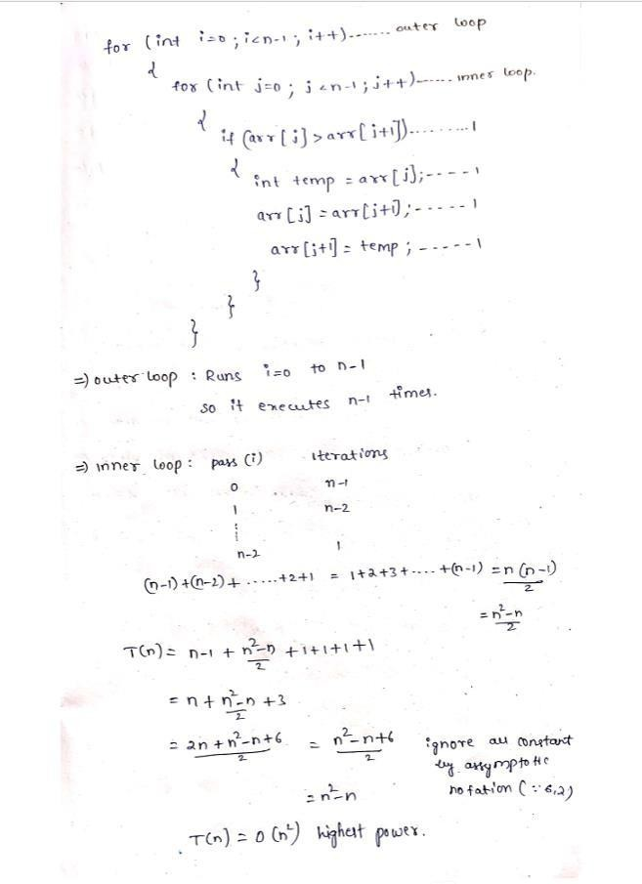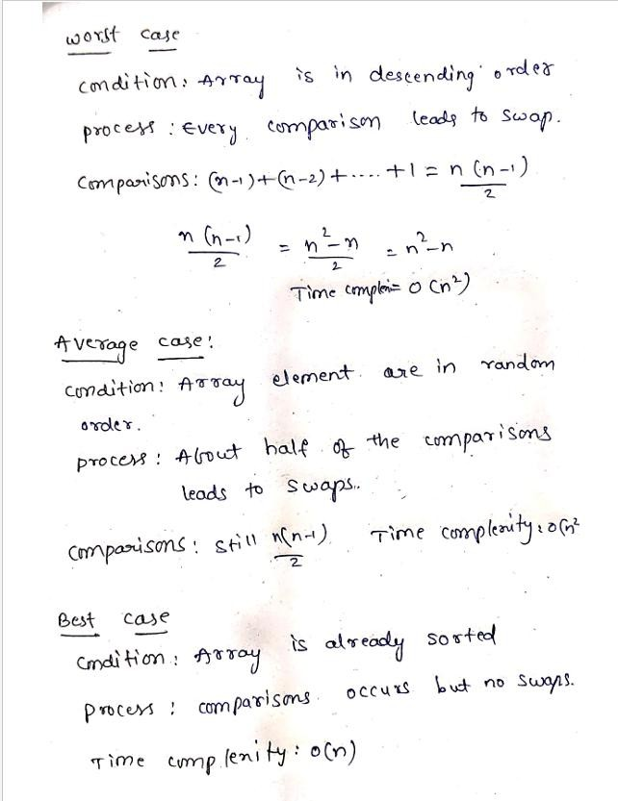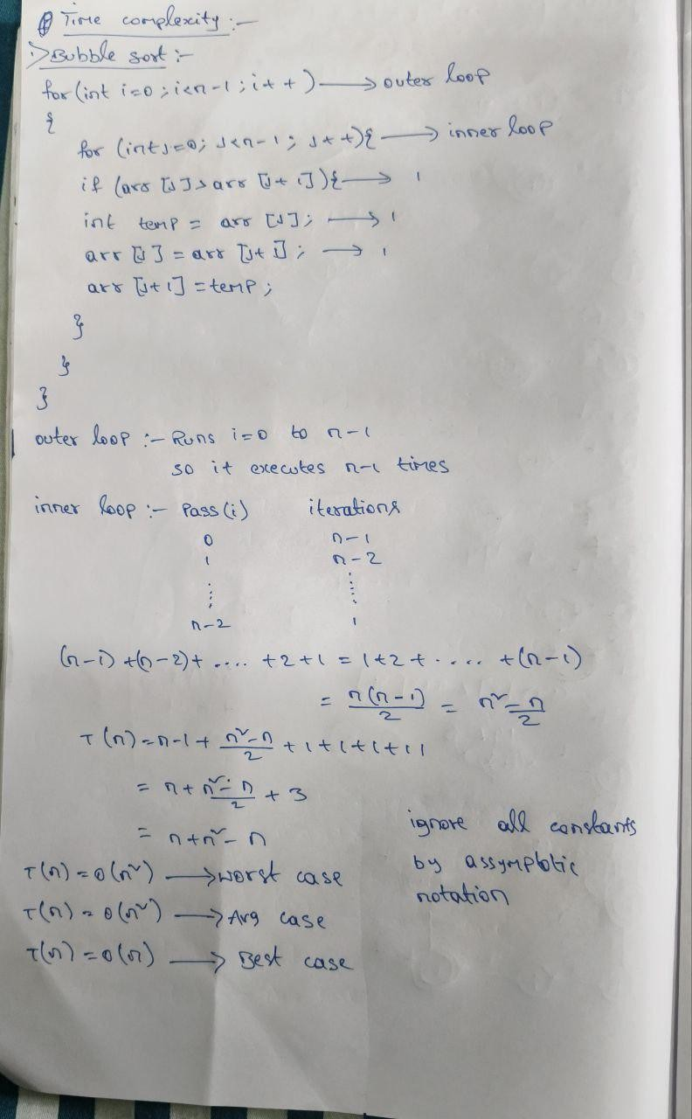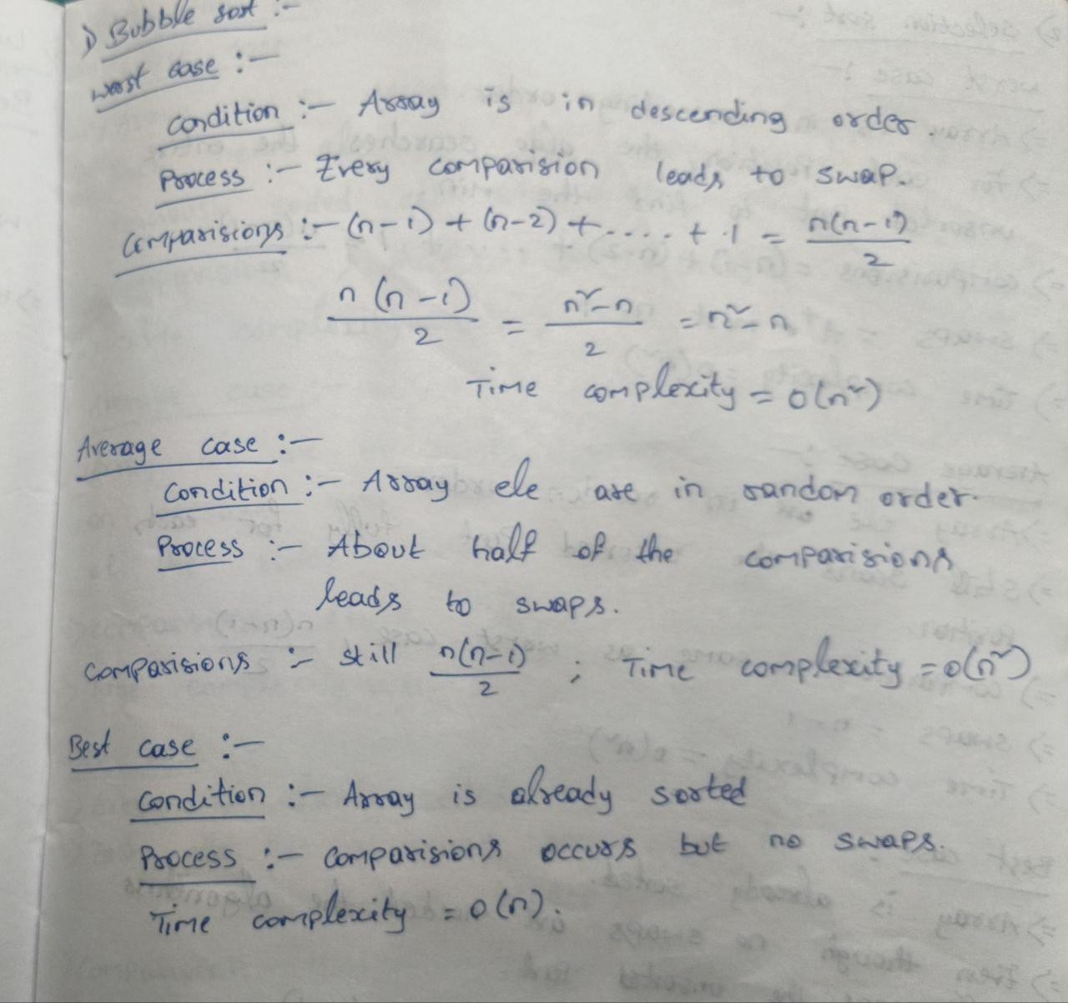

SELECTION SORT



ALGORITHM:

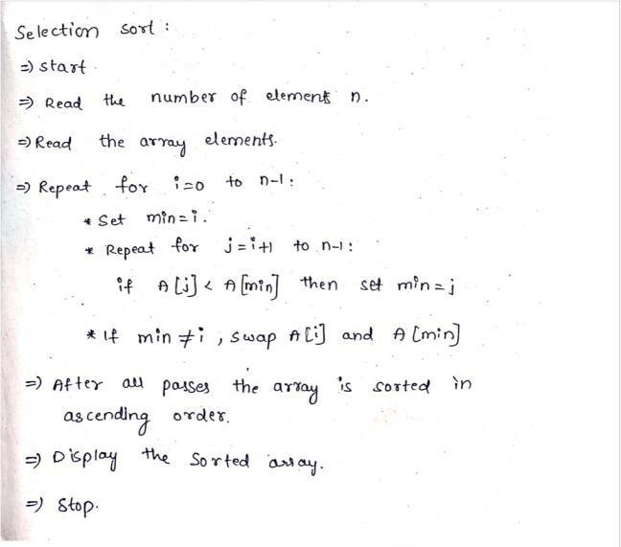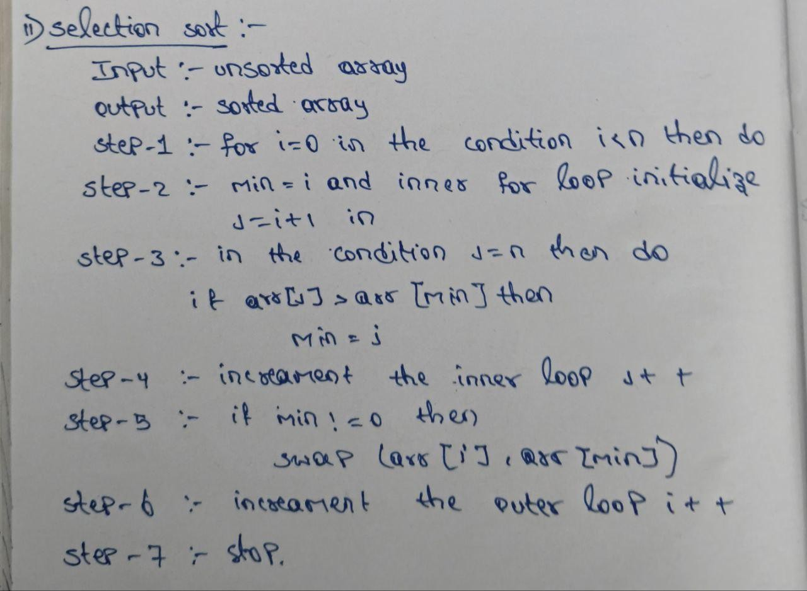

PROGRAM:
#include <iostream> using namespace std;

void selectionSort(int arr[], int n) { for (int i = 0; i < n - 1; i++) {
int minIndex = i;
for (int j = i + 1; j < n; j++) { if (arr[j] < arr[minIndex]) {
minIndex = j;
}
}

int temp = arr[minIndex]; arr[minIndex] = arr[i]; arr[i] = temp;
}
}
int main() {


int n;
cout << "Enter number of elements: "; cin >> n;

int arr[n];
cout << "Enter " << n << " elements: "; for (int i = 0; i < n; i++) {
cin >> arr[i];
}
cout << "Original array: "; for (int i = 0; i < n; i++)
{
cout << arr[i] << " "; cout << endl;
}
selectionSort(arr, n);

cout << "Sorted array: "; for (int i = 0; i < n; i++)
{
cout << arr[i] << " ";
//cout << endl;
}
return 0;
}

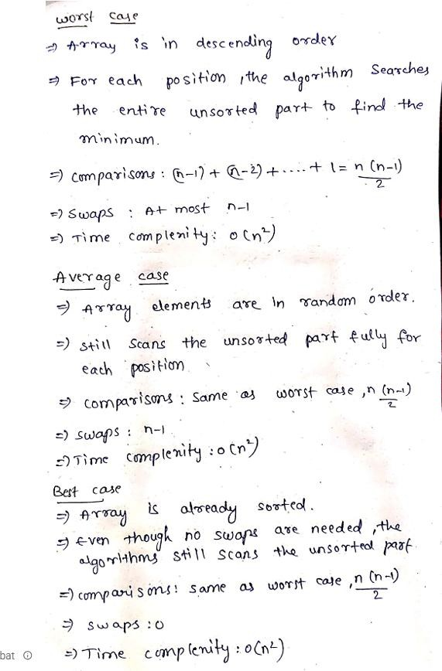
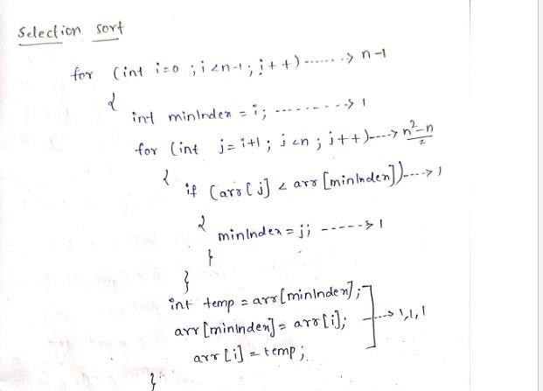
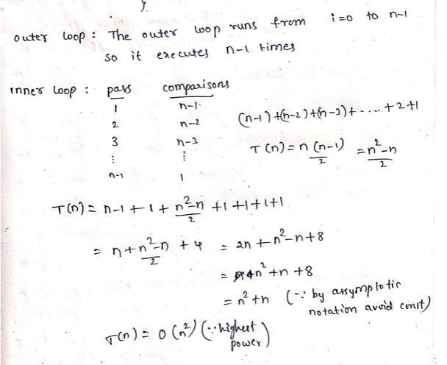
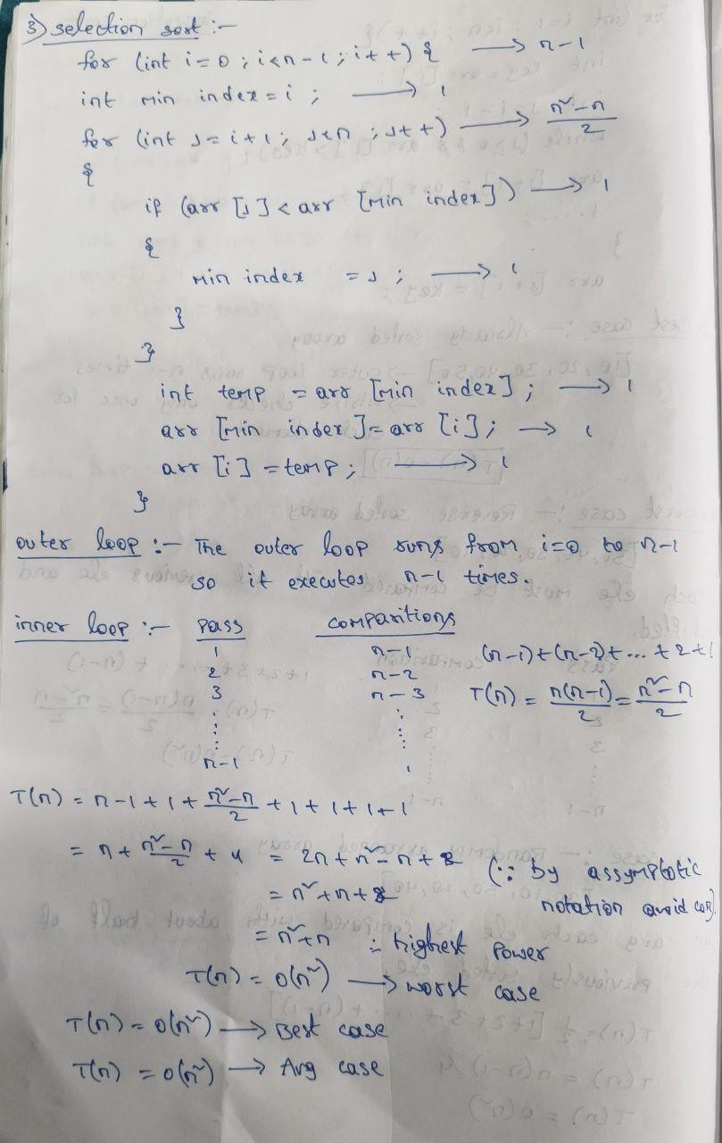
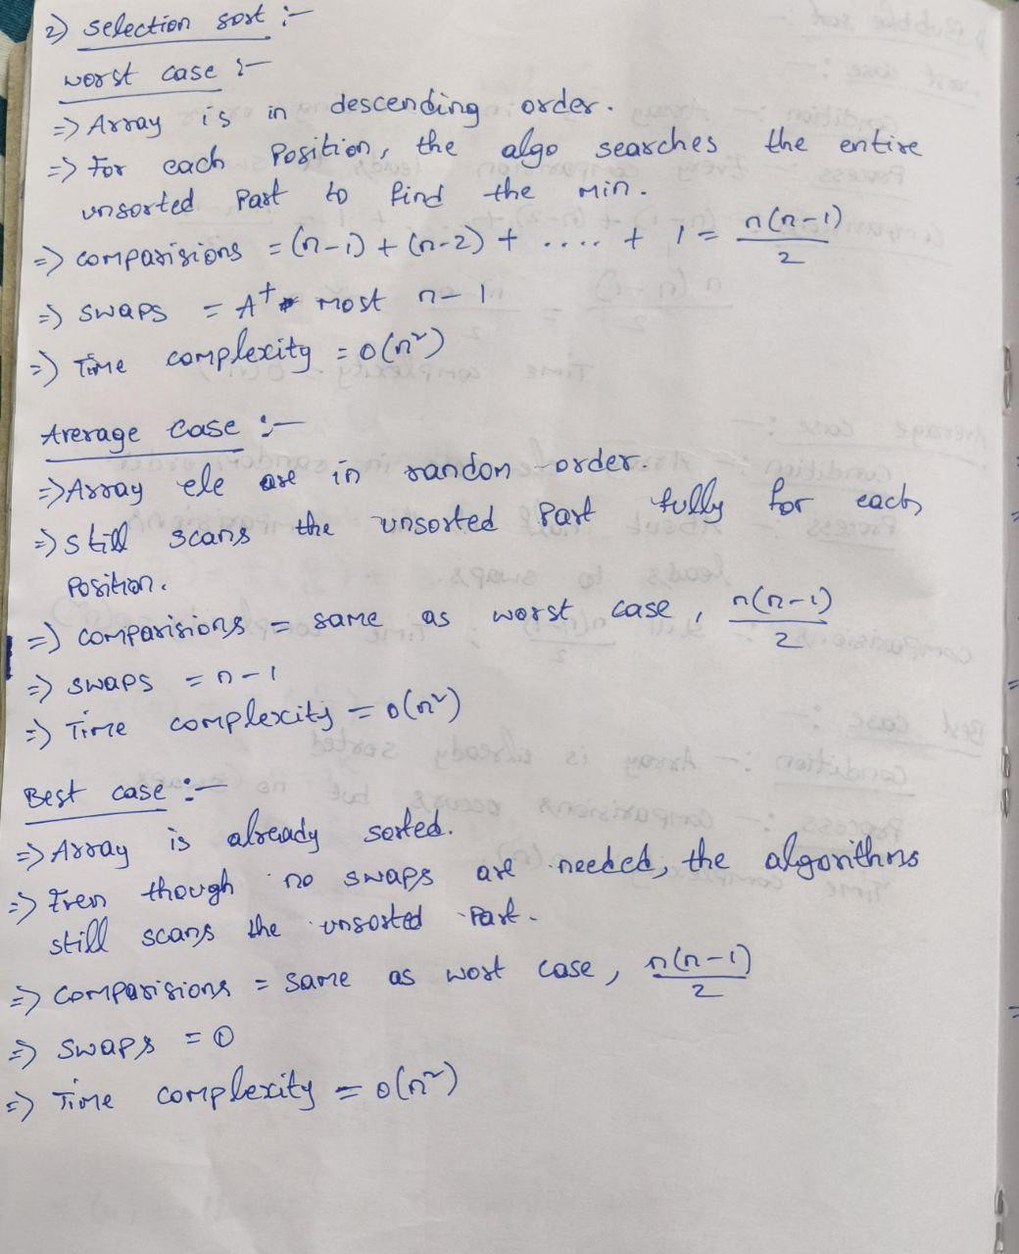




OUTPUT:
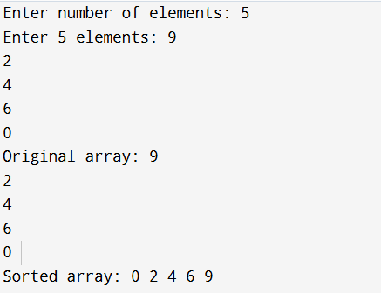

TIME COMPLEXITY:

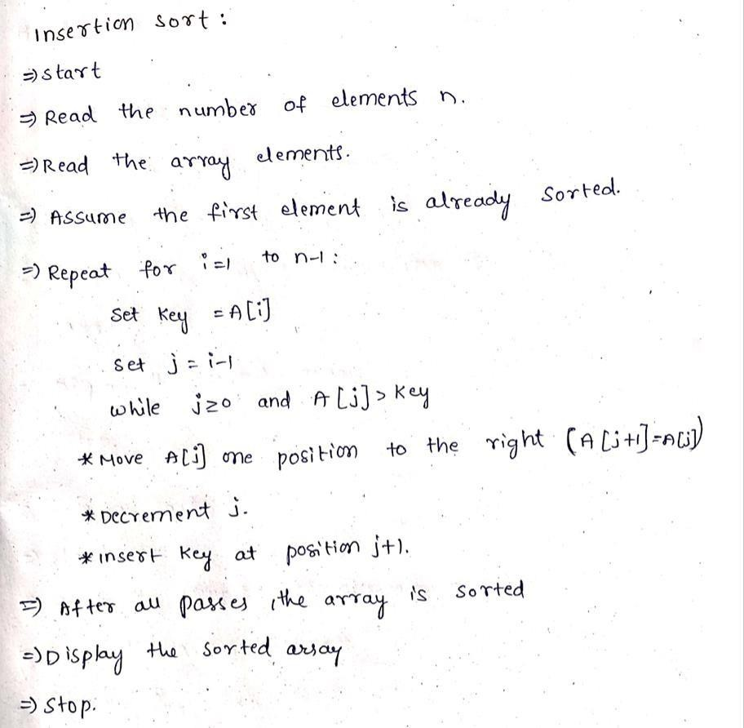
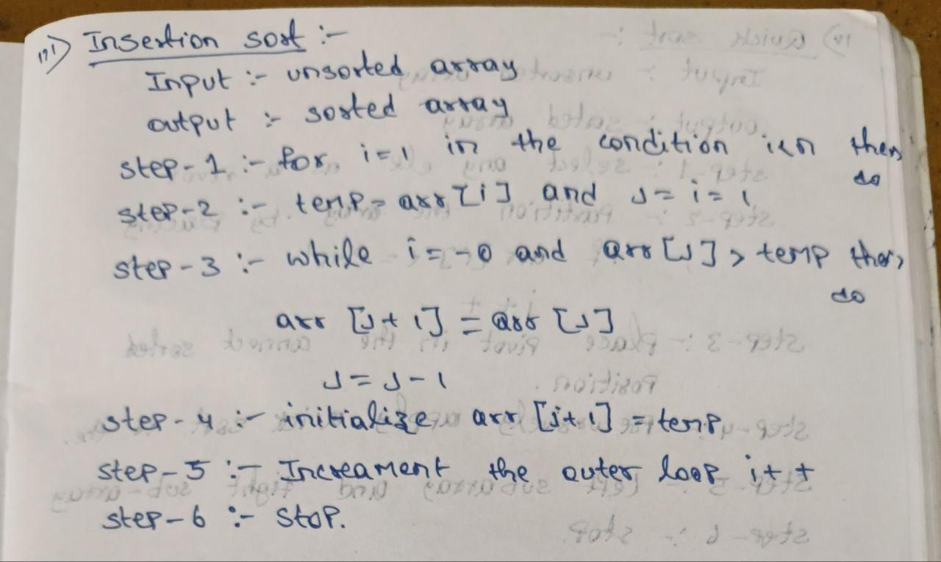


INSERTION SORT

ALGORITHM:

PROGRAM:
#include <iostream> using namespace std;

void insertionSort(int arr[], int n) { for (int i = 1; i < n; i++) {
int key = arr[i]; int j = i - 1;

while (j >= 0 && arr[j] > key) { arr[j + 1] = arr[j];
j--;
}
arr[j + 1] = key;
}


}

int main() { int n;
cout << "Enter number of elements: "; cin >> n;

int arr[n];
cout << "Enter " << n << " elements: "; for (int i = 0; i < n; i++) {
cin >> arr[i];
}

cout << "Original array: "; for (int i = 0; i < n; i++)
{
cout << arr[i] << " "; cout << endl;
}
insertionSort(arr, n);

cout << "Sorted array: "; for (int i = 0; i < n; i++)
{
cout << arr[i] << " ";
//cout << endl;
}
return 0;
}

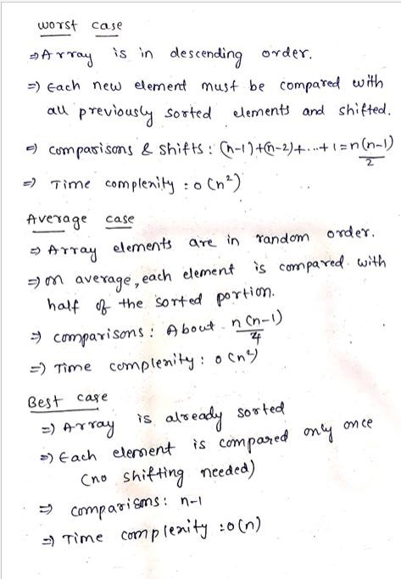
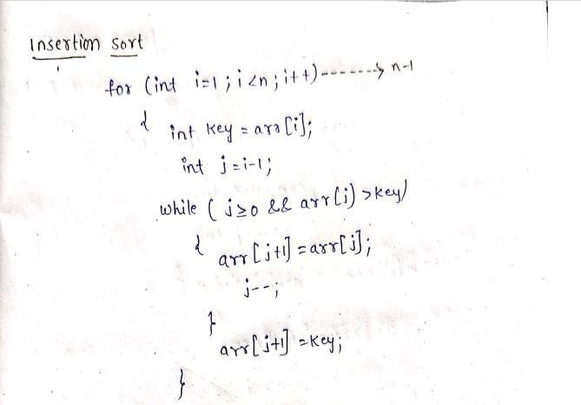
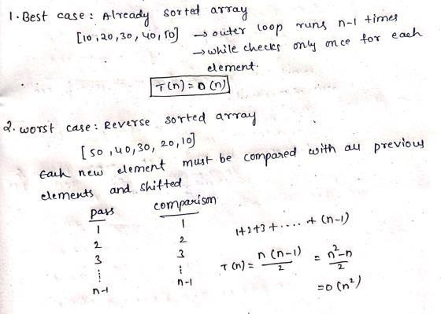
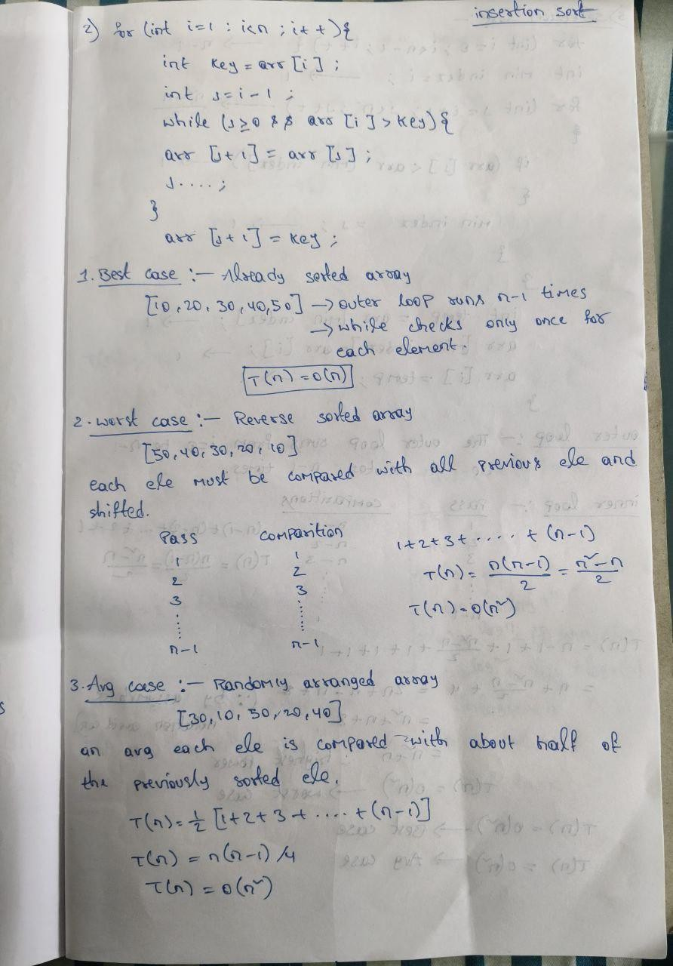
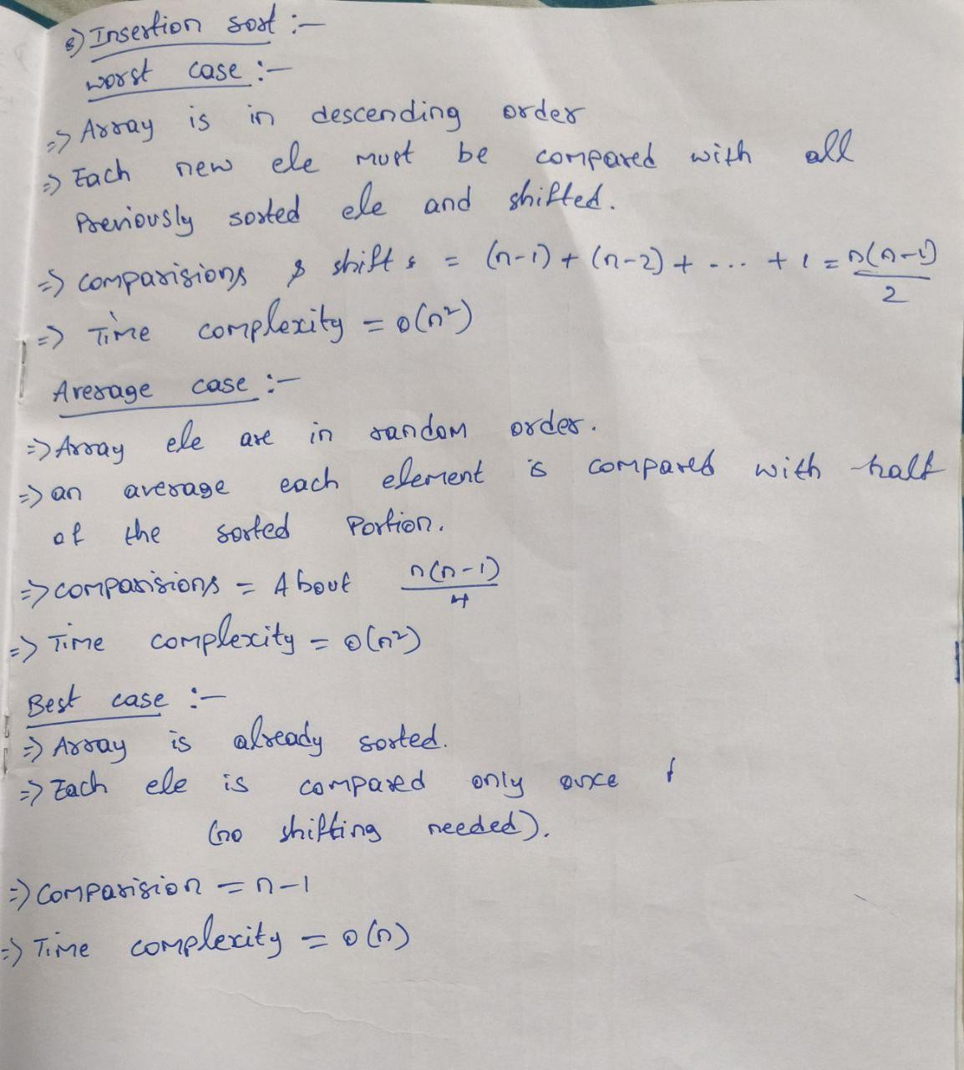




OUTPUT:
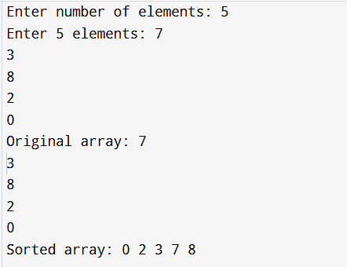

TIME COMPLEXITY:



QUICK SORT

ALGORITHM:

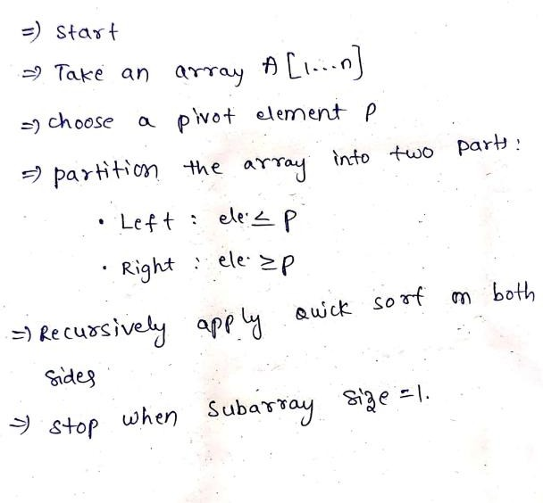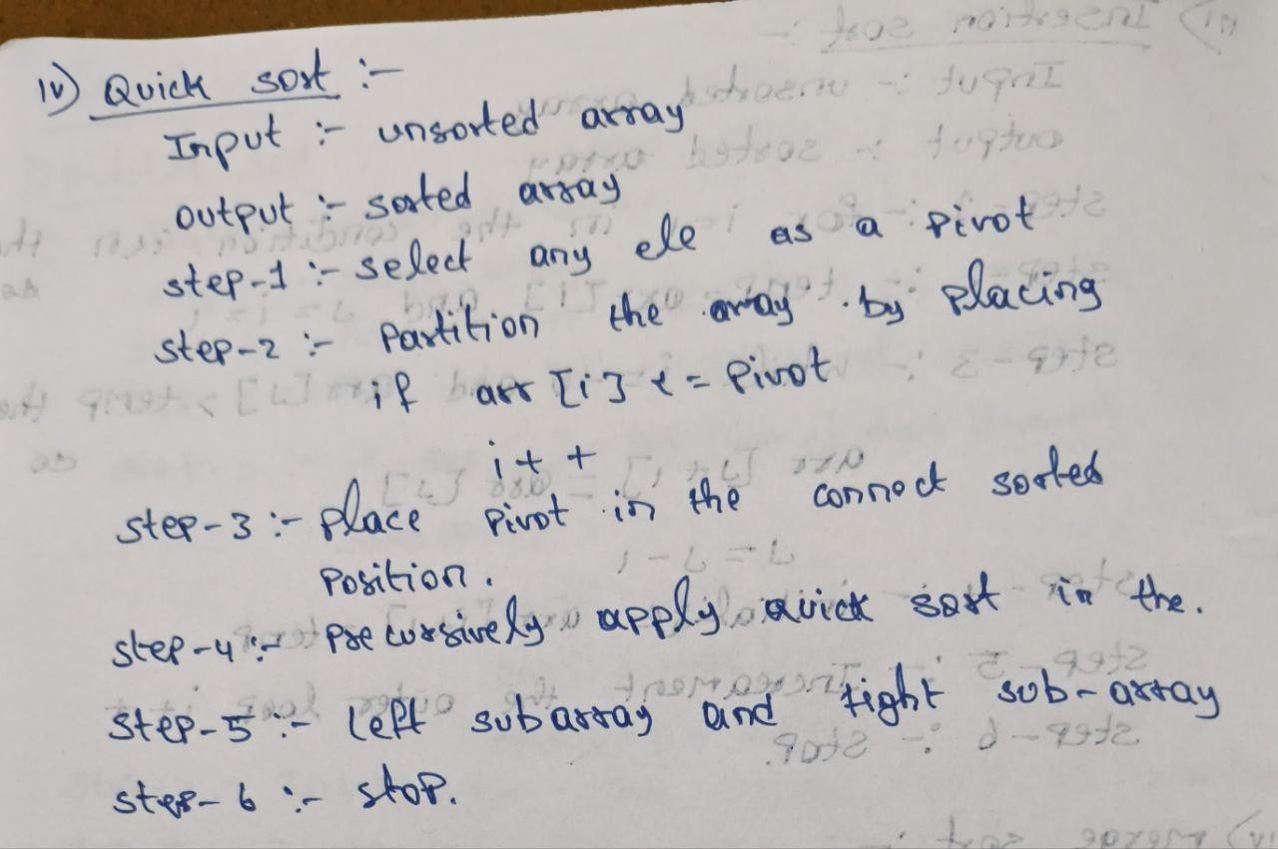

PROGRAM:

#include <iostream> using namespace std;
int partition(int arr[], int lb, int ub) { int pivot = arr[lb];
int start = lb; int end = ub;

while (start < end) {
while (arr[start] <= pivot ) { start++;
}
while (arr[end] > pivot) { end--;



}

if (start < end) { swap(arr[start], arr[end]);
}
}
swap(arr[lb], arr[end]); return end;
}

void quickSort(int arr[], int lb, int ub) { if (lb < ub) {
int loc = partition(arr, lb, ub); quickSort(arr, lb, loc - 1); quickSort(arr, loc + 1, ub);
}
}
int main() { int n;
cout << "Enter size of array: "; cin
>> n;

int arr[n];
cout << "Enter " << n << " elements: "; for (int i = 0; i < n; i++) {
cin >> arr[i];
}



quickSort(arr, 0, n - 1);

cout << "Sorted array: "; for (int i = 0; i < n; i++) { cout
<< arr[i] << " ";
}
return 0;
}

OUTPUT:
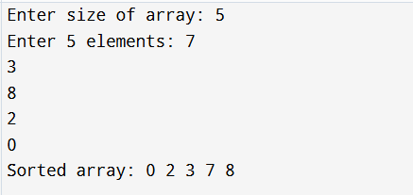

TIME COMPLEXITY:
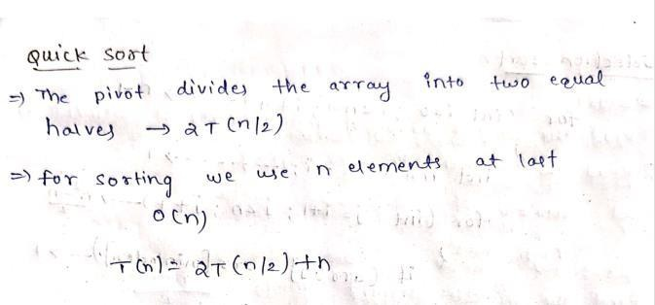


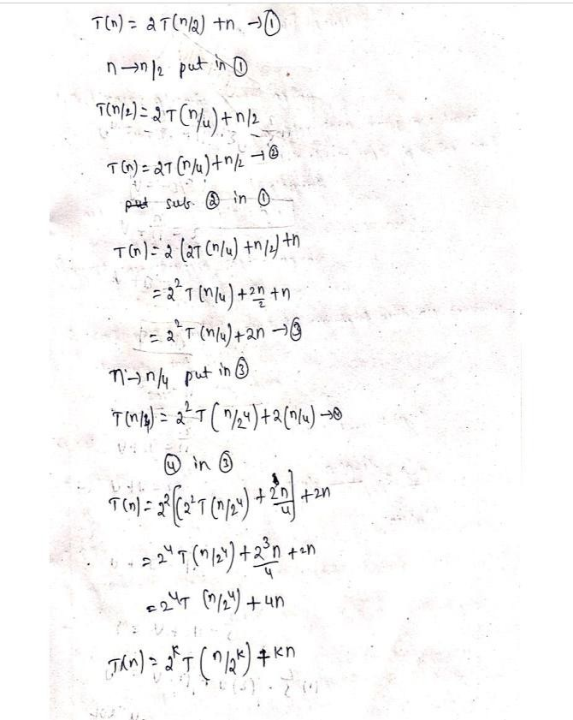
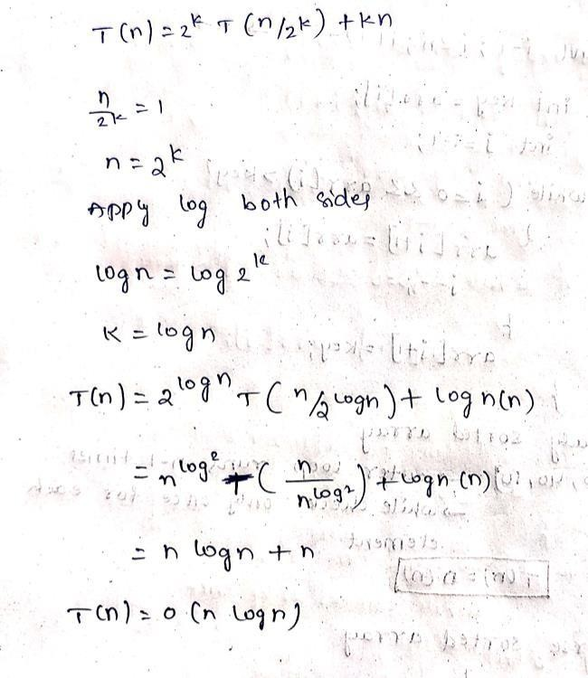
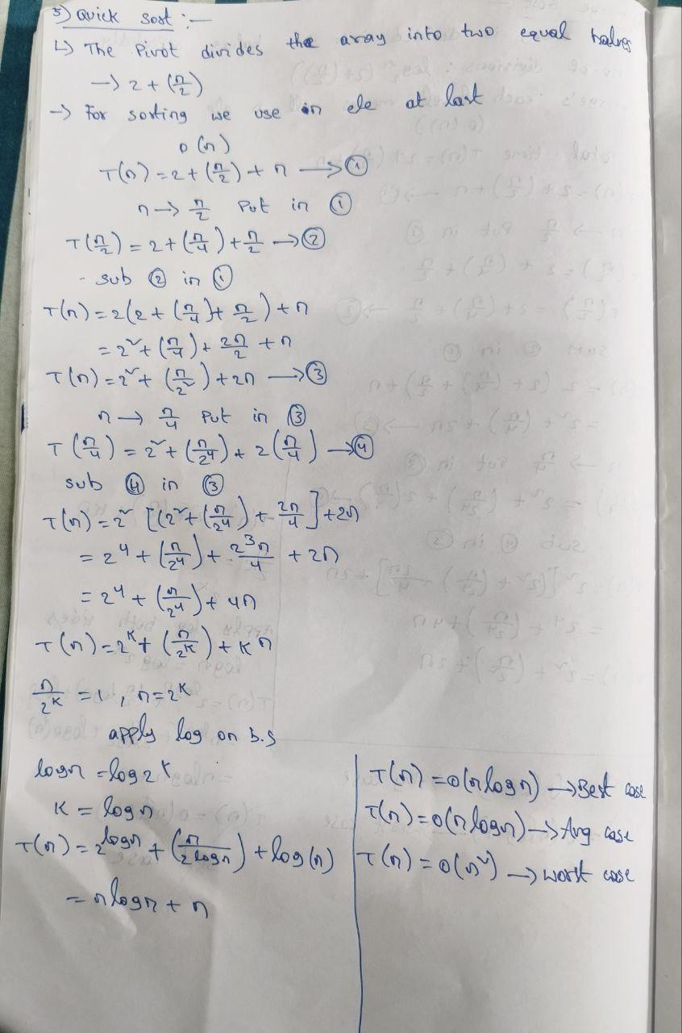





MERGE SORT

ALGORITHM:

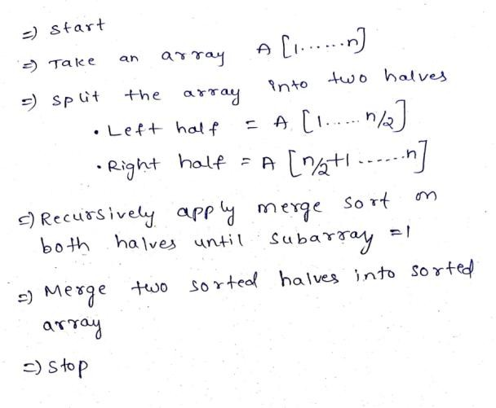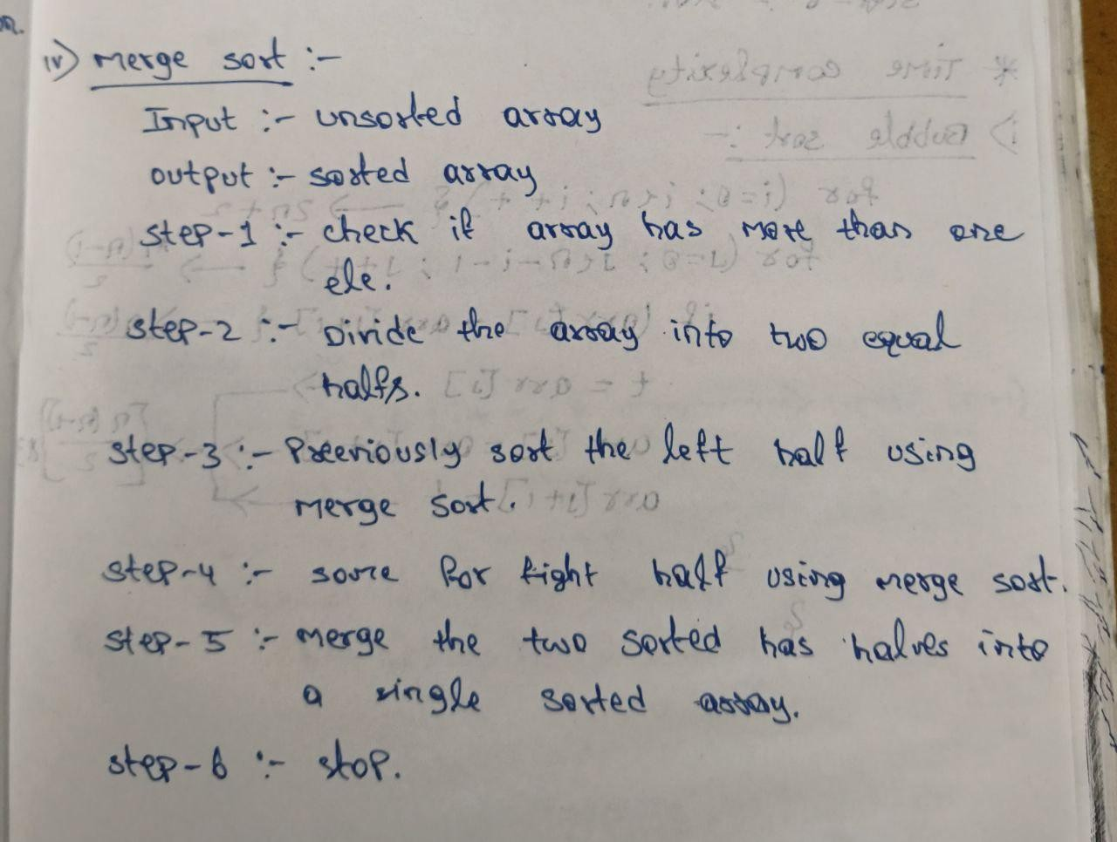

PROGRAM:
#include <iostream> using namespace std;

void merge(int arr[], int left, int mid, int right) { int n1 = mid - left + 1;
int n2 = right - mid; int L[n1], R[n2];
for (int i = 0; i < n1; i++) L[i] = arr[left + i];
for (int j = 0; j < n2; j++) R[j] = arr[mid + 1 + j];

int i = 0, j = 0, k = left; while (i < n1 && j < n2) {
if (L[i] <= R[j]) arr[k++] = L[i++]; else arr[k++] = R[j++];
}
while (i < n1) arr[k++] = L[i++]; while (j < n2) arr[k++] = R[j++];
}



void mergeSort(int arr[], int left, int right) { if (left < right) {
int mid = left + (right - left) / 2; mergeSort(arr, left, mid); mergeSort(arr, mid + 1, right); merge(arr, left, mid, right);
}
}
int main() { int n;
cout << "Enter number of elements: "; cin
>> n;
int arr[n];
cout << "Enter elements: ";
for (int i = 0; i < n; i++) cin >> arr[i];

mergeSort(arr, 0, n - 1);

cout << "Sorted array: ";
for (int i = 0; i < n; i++) cout << arr[i] << " "; return 0;
}

OUTPUT:
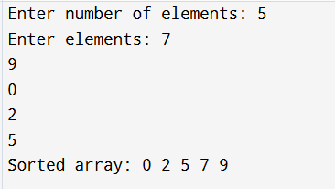

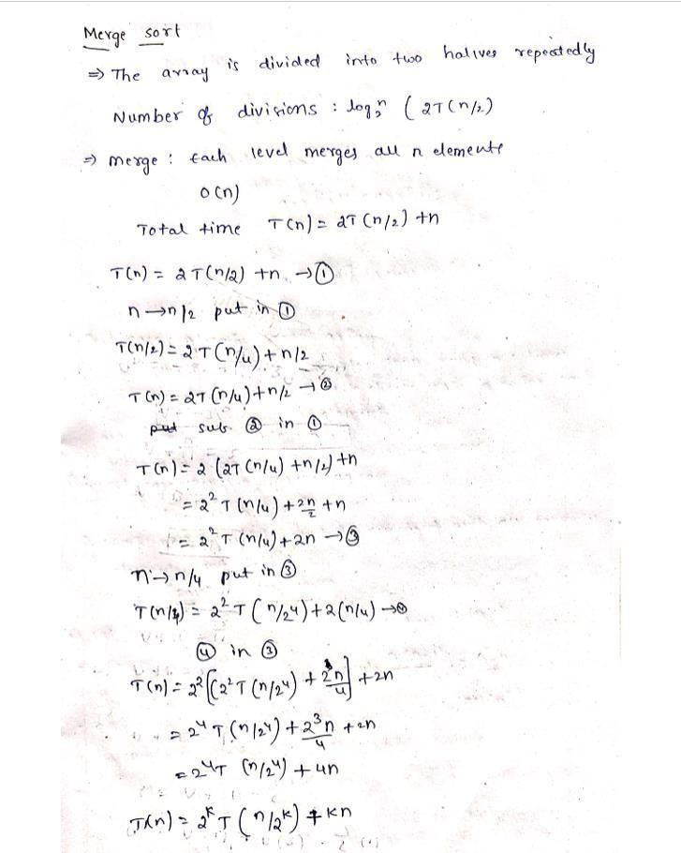
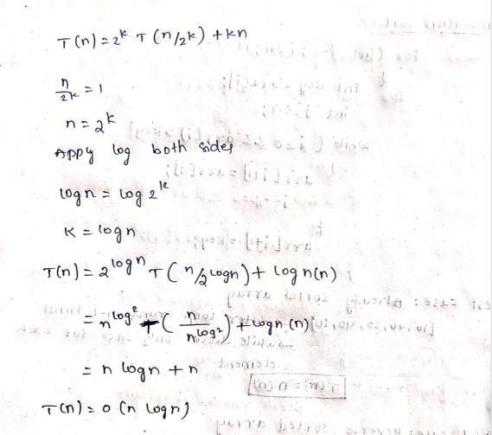
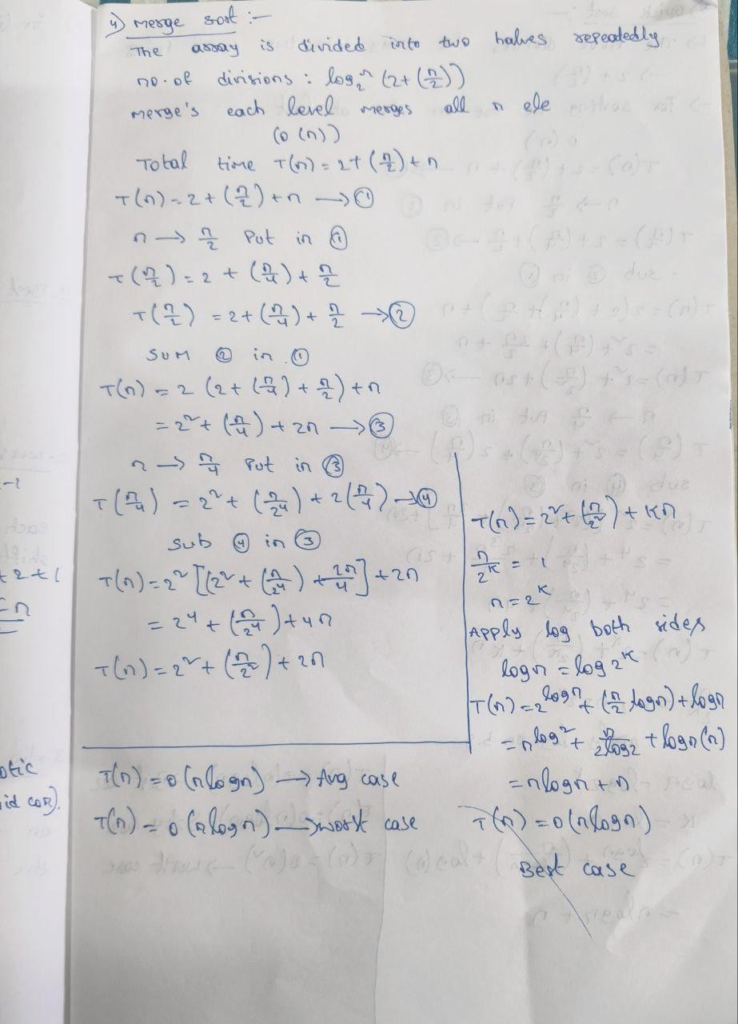



TIME COMPLEXITY:



CONCLUSION:
Bubble Sort and Selection Sort are simple but inefficient with 𝑂(𝑛²)in all major cases. Insertion Sort improves to 𝑂(𝑛)in the best case when the array is already sorted. Quick Sort is very efficient on average with 𝑂(𝑛 log 𝑛), though it can degrade to 𝑂(𝑛²). Merge Sort is consistently 𝑂(𝑛 log 𝑛)in all cases but requires extra space.

